2026 CAPGEMINI TEST - 3

Test Summary

* No. of Sections: 3
* No. of Questions: 47
* Total Duration: 90 min

Section 1 - VERBAL

Section Summary

* No. of Questions: 20
* Duration: 20 min

Additional Instructions:

None

Q1.

**Mark the option which best expresses the sentence in passive voice:**

One of the boys in the group will sing the anthem at the end of the memorial.

A boy to sing anthem is there in the group

one of the boys in the group would sing the anthem at the end of the memorial

The memorial will end, a boy one of the boys in the group at the end of the memorial

The anthem will be sung by one of the boys in the group at the end of the memorial

Q2.

**Which part of the sentence below has an error in it?**

A broken plate / lay sprayed / across the corridor.

across the corridor

A broken plate

lay sprayed

no error

Q3.

Choose the option which best expresses the given sentence in passive voice.

I ate an apple on my way here.

An apple was eaten by me on my way here

An apple was being eaten by me on my way here

My apple was eaten on my way here

I came here eating an apple

Q4.

Choose whether the statement given below is a fact, an inference, or a judgement.

It'll break her heart to know you kept these secrets!

judgement

fact

inference

Q5.

**Mark the option which best expresses the given sentence in Indirect speech.**

The tourist said, " Can you show me the way to the closest hotel?"

The tourist request the man if he can show him the way to the closest hotel

The tourist asked that will he show him the way to the closest hotel

The tourist requested the man if he will show him the way to the closest hotel

The tourist asked the man whether he would show him the way to the closest hotel

Q6.

Which part of the sentence below has an error in it?

When she played / the guitar, it seem like / she was in heaven.

the guitar, it seem like

she was in heaven

when she played

no error

Q7.

Mark the option which best expresses the sentence in passive voice.

She taught me to read French.

french reading is taught by her

she teaches me to read French

she is teaching me French reading

I was taught to read French by her

Q8.

**Which part of the sentence below has an error in it?**

Joe put the letter / carefully onto the bed / beside him and reached / into the box for the robot.

into the box for the robot

beside him and reached

carefully onto the bed

Joe put the letter

Q9.

**Read the statement given below and decide whether it is a fact, an inference, or a judgement:**

The sales of product XYZ have decreased drastically over the years.

judgement

inference

fact

Q10.

Choose the correct sequence of the given words/phrases so that it forms a logical sentence.

The ON Guiding Principles on Business and Human rights highlight the duty of the state to __1____ workers against rights abuses, and the reason to respect human rights.

cause

effect

protect

Q11.

Which part of the sentence below has an error in it?

The other lawyer's fees would / have been harder to pay; / I'm glad this one turned out / to be your nephew

The other lawyer's fees would

to be your nephew

I'm glad this one turned out

have been harder to pay;

Q12.

A sentence is broken into the following parts. Mark the option containing the correct sequence of these parts to get the complete sentence.

1.trantz stopped short of conceding default.

2.of disappointment and pain

3.saying that the election could result in another deadlock

4.And he understood and shared his supporters' feelings

2314

1342

2341

1234

Q13.

The question given below contains a sentence with certain words underlined. These words may or may not be correct grammatically, Marks the option that contains the error and the correction suggested.

The exploits of this entire community of queens make one of the most extraordinary episodes in the story of medieval France.

exploit

exploited

exploitation

no error

Q14.

Mark the option which best expresses the given sentence in indirect speech

The professor said, 'Be silent and listen to my lecture'

The professor said they should be silent and listen to him

The professor said them to be silent and listen to his lecture

The professor urged them to be silent and listen to his lecture

The professor told them that they should be silent and listen to his lecture

Q15.

**Given below are sentence which arranged logically form a coherent passage Choose the option which given:**

1. Unless there are no laws and regulations, soon there will be chaos everywhere.
2. We follow the rules and regulations since discipline is essential to us.
3. Since human beings are social creatures, we are experts to live with society's laws and regulations.
4. We should seek the spirit of discipline in every walk of our lives.

1234

4321

2341

1324

Q16.

Make the option that contains the word(s) that fits in the blank.

I ___1___ at the ability of the children to lie with the confidence that they can. I was recently walking to the playground with my seven years old girl.

Which of these fits in blanks 1?

marvel

ponder

shrug

abhor

Q17.

He told me he had ___1___ his milkshake that we had just picked up from the shop when I could see the cup was still half full.

Which of these fits blank 1?

finished

bummed

closed

completed

Q18.

In the following sentence, some part or whole sentence is underlined. Below are given four ways of phrasing the underlined part, select the correct among the choice which produces the most effective sentence, one that is clear and exact?

Three distressing trends have dominated politics in the last decade: polarisation of polity, rise tribalism and the tendency to encourage and defections.

over the last decade; polarisation of polity, rise of tribalism

for the last decade; polarisation of polity , rise of tribalism

over the last decade; polarisation of polity, the rise of tribalism

in the last decade ; polarisation of polity, rise of tribalism

Q19.

Which part of the sentence below has an error in it?

Art doesn't / has to / be intentional.

has to

be intentional.

Art doesn't

no error

Q20.

**Which part of the sentence below has an error in it?**

If his misery/ is due to some ill lucky,/ he is deserving sympathy.

is due to some ill lucky

he is deserving sympathy.

no error

If his misery

Section 2 - Q&R

Section Summary

* No. of Questions: 15
* Duration: 20 min

Additional Instructions:

None

Q1.

Number Puzzle: Find the missing number?

12

16

18

110

Q2.

 In how many minimum numbers of steps you can move the red ball to the hole

﻿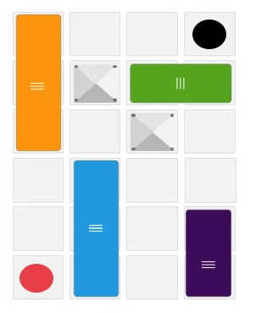

7 steps

8 steps

6 steps

5 steps

Q3.

Select a suitable figure from the four alternatives that would complete the figure matrix.

1

2

3

4

Q4.



is equal to

0

1

2

3

Q5.

A speaks truth in 60% and B in 80% of the cases. In what percentage of cases are they likely to contradict each other narrating the same incident?

44%

36%

64%

48%

Q6.

I walk to a town at 3½ kmph, rest there for 45 minutes and ride back at 7½ kmph. Find the distance to the town, if the total time spent by me is 6 hrs 37 minutes,

14 km

7 km

5 km

8 km

Q7.

A certain number consists of two digits whose sum is 9. If the order of digits is reversed, the new number is 9 less than the original number. The original number is

45

36

54

63

Q8.

Bharat has started from his house, walked 12 m towards North, took a right turn and then walked 5 m to reach his office. Find the shortest distance and the direction of his office with respect to his home.

17 m North-west

13 m South-west

13 m South-east

13 m North-east

Q9.

In the adjoining diagram, if quadrilateral ABCD is inscribed in the circle, then which triangle is similar to ∆BEC?

∆ABC

∆ADE

∆DBC

∆ADB

Q10.

How many digits are required to number a book containing 200 pages?

200

600

492

372

Q11.

In the given figure, DE||BC. If DE = 4 cm, BC = 8 cm and area of ∆ADE = 25 sq. cm, then the area of ∆ABC is

70 sq cm

100 sq cm

150 sq cm

None of these

Q12.

In the following questions the first and last blocks mark the beginning and the end of a series respectively. The numbered blocks are a part of the series. However, one of these numbered blocks violates the pattern. Find the odd block and mark your answer from 1-5 accordingly.

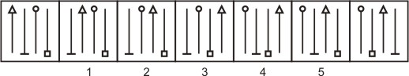

1

2

3

4

5

Q13.

A certain sum of money is distributed between two friends in the ratio 5 : 11. If one of them gets Rs.1250 more than the other, then the sum is

> Rs.3000

< Rs.3000

< Rs.2800

> Rs.4000

Q14.

The solution of the equations 4x + 6y = 3xy and 8x + 9y = 5xy is given by

x = 1, y = 2

x = 2, y = 3

x = 1, y = –1

x = 3, y = 4

Q15.

Three partners invested capital in the ratio 2 : 7 : 9. The time period for which each of them invested was in a ratio of the reciprocals of the amount invested. Find the share of the partner who bought in the highest capital, if profit is Rs.1080.

Rs.540

Rs.360

Rs.420

Rs.720

Section 3 - TECHNICAL

Section Summary

* No. of Questions: 12
* Duration: 50 min

Additional Instructions:

None

Q1.

Datatypes are different on the basis of _______.

the way of storage

the type of operations

the type of operators used

the way of storage and the type of operations

Q2.

James is using heap sort to sort an array in increasing order. What is the overall time complexity of the sorting technique used by him?

log n

n

n logn

n * n

Q3.

What will be the output of the following pseudocode?

5

9

15

4

Q4.

The following steps in a linked list, result in which type of operation?

Pop operation in stack

Removal of a node

Inserting a node

Modifying an existing node

Q5.

What will be the output of the following C++ code?

11

12

21

22

Q6.

What is the first line in the following code that has not been compiled?

k1

k2

k3

None of the mentioned options

Q7.

What will be the output of the following pseudocode?

12345

1234

123

12

1

1 2 3 4 5

1 2 3 4

1 2 3

1 2

1

12345

1234

123

12

1 2 3 4 5

1 2 3 4

1 2 3

1 2

Q8.

What happens when you try to access an array variable outside of its size?

Compiler error is thrown

0 value will be returned

1 value will be returned

Some garbage value will be returned

Q9.

What will be the output of the following program?

value of g = 20

Compile Time Error

value of g = 10

Garbage value

Q10.

Which of the following changes to typical QuickSort improves its performance on average and are generally done in practice?

1. Randomly picking up to make worst-case less likely to occur.
2. Calling insertion sort for small-sized arrays to reduce recursive calls.
3. QuickSort is tail recursive, so tail call optimizations can be done.
4. A linear time median searching algorithm is used to pick the median so that the worst-case time reduces to O(N log N)

1 and 2

2, 3, and 4

1, 2 and 3

2 and 4

Q11.

Given a string str, print reverse of all words except the first and last words.

Input Format

Input contains a sentence

Output Format

Output is displayed as shown in sample test cases

Sample Input

Hi how are you folks

Sample Output

Hi woh era uoy sklof

Sample Input

I am fine

Sample Output

I ma fine

Time Limit: 10 ms Memory Limit: 256 kb Code Size: 1024 kb

Q12.

On looking at a two dimensional array, Samir can find out the number of perfect squares among the array elements.Help him a write a computer program that does the same operation.

Input Format

First line consists of the rows and columns to be present in the array; The elements of the array are given in the consecutive lines representing an r x c matrix.

Output Format

Output is displayed as shown in the sample test cases according to the scenario.

Constraints

Maximum number of rows and columns = 10

Sample Input Sample Output

3 3

56-8 5

-6 8 9

7 4 19

Sample Output

2 Perfect Squares.

Sample Input

-8 -6

Sample Output

Invalid Rows or columns

Sample Input

1 6

8 5 19 24 53 78

Sample Output

No Perfect Squares.

Time Limit: 10 ms Memory Limit: 256 kb Code Size: 1024 kb

Answer Key & Solution

Section 1 - VERBAL

Q1

The anthem will be sung by one of the boys in the group at the end of the memorial

Solution

The sentence is in Simple Future Tense. (Active)

The anthem will be sung by one of the boys in the group at the end of the memorial. (Passive)

Q2

lay sprayed

Solution

A broken plate lays/laid sprayed **in the corridor.**

Q3

An apple was eaten by me on my way here

Solution

Passive voice - An apple was eaten by me on my way here

Q4

inference

Solution

**Inference**

* **Fact:** A fact is an objective statement that can be verified.
* **Inference:** An inference is a conclusion drawn based on evidence or observations.
* **Judgement:** A judgement expresses an opinion or belief.

The statement "It'll break her heart to know you kept these secrets!" doesn't definitively state something that can be proven. It predicts an emotional reaction ("break her heart") based on an assumption about her feelings towards the secrets. This assumption might be true, but it's not a guaranteed outcome.

Q5

The tourist asked the man whether he would show him the way to the closest hotel

Solution

Reported speech: The tourist asked the man whether he would show him the way to the closest hotel.

Q6

the guitar, it seem like

Solution

Sentence is in past tense. so, the error is in second part.

Error part - ***the guitar, it seem like***

Q7

I was taught to read French by her

Solution

Passive voice - I was taught to read French by her.

Q8

Joe put the letter

Solution

**Joe put the letter** / carefully onto the bed / beside him and reached / into the box for the robot.

Past perfect verb should have been used in the first part.

Q9

inference

Solution

No Solution

Q10

protect

Solution

No Solution

Q11

The other lawyer's fees would

Solution

**The other lawyer's fees would** / have been harder to pay; / I'm glad this one turned out / to be your nephew.

Fee should have been used instead of fees.

Q12

1342

Solution

1.trantz stopped short of conceding default 3.saying that the election could result in another deadlock 4.And he understood and shared his supporters' feelings 2.of disappointment and pain

1342 is the correct order.

Q13

no error

Solution

The sentence uses the word "exploits" correctly.

"Exploits" in this context refers to the queens' noteworthy achievements or deeds. It suggests the community's actions were impressive and contributed to a remarkable chapter in French history.

Q14

The professor urged them to be silent and listen to his lecture

Solution

Reported Speech: The professor urged them to be silent and listen to his lecture.

Q15

2341

Solution

3 provides a general statement about humans and society.

2 explains why we follow the rules (because discipline is essential).

4 suggests that discipline should be sought in all areas of life.

1 states the consequence of not having laws and regulations, supporting the importance of the previous points.

The corresponding option is: **2341**

Q16

marvel

Solution

marvel - be filled with wonder or astonishment.

ponder - think about (something) carefully, especially before making a decision or reaching a conclusion.

shrug - raise (one's shoulders) slightly and momentarily to express doubt, ignorance, or indifference.

abhor - regard with disgust and hatred.

marvel is the right choice.

Q17

finished

Solution

No Solution

Q18

over the last decade; polarisation of polity, the rise of tribalism

Solution

No Solution

Q19

has to

Solution

Art is used as singular like plural here. So, 'have' should have been used in the verb part.

Q20

is due to some ill lucky

Solution

If his misery/ is due to some ill **lucky**,/ he is deserving sympathy.

ill-luck is the right usage.

Section 2 - Q&R

Q1

12

Solution

Answer: 12

Explanation:

In the first column, 2 * 1 + 1 = 3.

In the second column, 14 * 7 + 7 = 105.

Let the missing number in the third column be x.

Then, x * 9 + 9 = 117 => 9x = 108 => x = 12.

Q2

5 steps

Solution

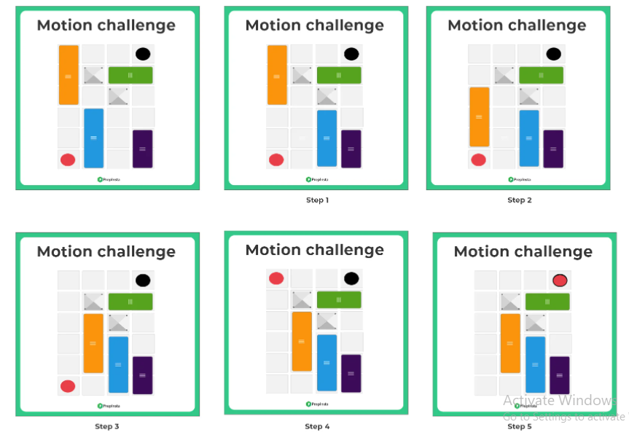

Q3

2

Solution

The two parts of the first figure are rearranged and joined along the longer sides. The common side is then lost to form the second figure.

Q4

2

Solution



= logabc (ab) + logabc (bc) + logabc (ca)

= logabc (abc)2 = 2.

Q5

44%

Solution

No Solution

Q6

14 km

Solution

Let the distance be D. D/3.5 + 45/60 + D/7.5 = 6(37/60) => D = 14 km.

Q7

54

Solution

Let ten's digit be x & unit digit be y.

Then, x + y = 9 & (10x + y) – (10y + x) = 9.

Solving x + y = 9 & x – y = 1, we get x = 5, y = 4

∴ Required number = 54.

Q8

13 m North-east

Solution

The path travelled by Bharat is as follows :

Let A be the house and B be the office.

Distance between A and B is given by AB

= √(AO2 + OB2)

=> AB = √(52 + 122) = 13 km

∴ Bharat's office is 13 m from his house and is in North-east direction.

Q9

∆ADE

Solution

Two triangles are similar if two of their corresponding angles are equal.

Angle AED = Angle BEC. (Vertically opposite angles).

Angle AOB = Angle ACB. (Inscribed angles of the same arc).

Triangle ADE is similar to triangle BEC.

Ans(2)

Q10

492

Solution

Number of one digit pages from 1 to 9 = 9

Number of two digit pages from 10 to 99 = 90

Number of three digit pages from 100 to 200 = 101

∴ The total number of required digits = 9 × 1 + 90 – 2 – 101 × 3 = 492. Ans(3)

Q11

100 sq cm

Solution

No Solution

Q12

5

Solution

The left most arrow changes its position with each one of the arrows on the right in a sequence, the other one follows the same sequence. In figure (5), the second arrow should have been the third one, the third arrow should have been the fourth one and the fourth arrow should have been the second one.

Ans.(5)

Q13

> Rs.3000

Solution

 Let the two shares be 5X and 11X.

=> 11X – 5X = 6X = Rs. 1250 => X = 208.33.

=> Total sum = 16X = 16 × 208.33 = Rs.3333.29 (> 3000).

Q14

x = 3, y = 4

Solution

Dividing each term of each of the given equations by xy, they become

= v, these equations become

6u + 4v = 3 and 9u + 8v = 5.

Solving these equations, we get and

. So, x = 3 and y = 4.

Q15

Rs.360

Solution

Share of A : B : C = 2 × ½ : 7 × 1/7 : 9 × 1/9 = 1 : 1 : 1,

Share of C = ⅓ × 1080 = Rs. 360

Section 3 - TECHNICAL

Q1

the way of storage and the type of operations

Solution

No Solution

Q2

n logn

Solution

The heapsort time complexity of O(n log n).

Q3

5

Solution

Initially pp=4, **qq=2**, Inside for loop :

rr=1,pp=2+1 =>**p= 3**, 2> 1(TRUE) so control comes out of the loop.

As a result, 3+2 = 5 gets printed.

Q4

Inserting a node

Solution

No Solution

Q5

12

Solution

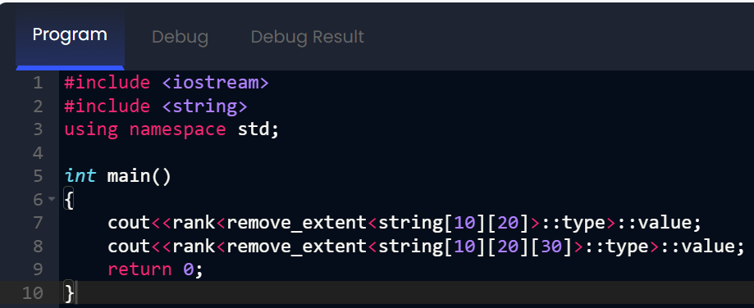

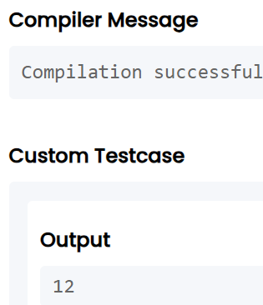

Q6

k2

Solution

Line by line analysis:

Line k1: int Integer = 0; - This line is valid. While "Integer" is the name of a class in Java, it can also be used as a variable name. This is confusing but legal.

Line k2: Integer int = 0; - This line has the first compilation error. You cannot use reserved keywords like "int" as identifiers/variable names. The compiler will reject this.

Line k3: Integer ++; - This line would be valid if the previous line was correct and Integer was a variable of a numeric type, but we don't reach this point due to the earlier error.

The first line that would not compile is line k2: Integer int = 0;

Q7

1 2 3 4 5

1 2 3 4

1 2 3

1 2

1

Solution

No Solution

Q8

Some garbage value will be returned

Solution

No Solution

Q9

Compile Time Error

Solution

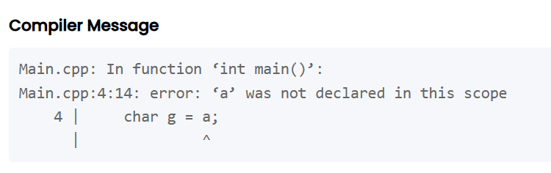

Q10

1, 2 and 3

Solution

No Solution

Q11

// CPP program to print reverse of all words

// except the corner words.

#include <bits/stdc++.h>

using namespace std;

void printReverse(string str)

{

// Print first word

int i = 0;

for (i = 0; i < str.length() && str[i] != ' '; i++)

cout << str[i];

// Print middle words

string word = "";

for (; i < str.length(); i++) {

if (str[i] != ' ')

word += str[i];

else {

reverse(word.begin(), word.end());

cout << word << " ";

word = "";

}

}

// Print last word

cout << word << " ";

}

int main()

{

string str;

getline(cin, str);

printReverse(str);

return 0;

}

Q12

Solution

#include<iostream>

#include<cmath>

using namespace std;

int main()

{

int r, c, count = 0;

long double sr;

cin>>r>>c;

if(r>0&&r<=10 &&c>0&&c<=10)

{

int arr[r][c];

for(int i=0;i<r;i++)

for(int j=0;j<c;j++)

{

cin>>arr[i][j];

sr = sqrt(arr[i][j]);

if ((sr - floor(sr)) == 0)

count++;

}

if(count!=0)

cout<<count<<" Perfect Squares.";

else

cout<<"No Perfect Squares.";

}

else

cout<<"Invalid Rows or columns";

return 0;

}

Top of Form

Bottom of Form

Top of Form

Bottom of Form